**Name:** Keyur patel

**Batch & Roll no:** A2-16010421073

**Tutorial Name :** Tut3-R2 : Continuous Probability Distribution-CO1

**Date :** 16/2/2023

Probability Distribution

INSTRUCTION :Create a word file of the program using the following

|  |  |  |
| --- | --- | --- |
| Steps | Details | Marks (25) |
| 1 (on the top of page) | Name:  Batch :  Roll no:  Tut3-R2 : Continuous Probability Distribution-CO1  Date: | 1 |
| 2 | File name  R2-RollNo-Batch no_Name  Eg.  R1-16010421001-A1-TANUSHREE ACHARYA | 1 |
| 3 | Question1  Code on Rstudio  Output(print screen of all4 windows together) | 1  2  2 |
| 4 | Question2  Code on Rstudio  Output(print screen of all4 windows together) | 1  2  2 |
| 5 | Question3  Code on Rstudio  Output(print screen of all4 windows together) | 1  2  2 |
| 6 | Question4  Code on Rstudio  Output(print screen of all4 windows together) | 1  2  3 |
| 7 | Submission during tutorial time | 2 |

Commands for Distribution

|  |  |  |  |  |
| --- | --- | --- | --- | --- |
| Distribution | R-name | parameters | Command | Purpose |
| Binomial Distribution | binom | n,p | dbinom(x, n,p) | Gives probability P(X=x) |
| pbinom(x, n,p) | cumulative probability P(X<=x) |
| Poisson Distribution | pois | m | dpois (x,m) | Gives probability P(X=x) |
| ppois (x,m) | cumulative probability P(X<=x) |
| Exponential Distribution | exp | pa=λ  =1/mean | dexp(x,pa) | Gives probability P(X=x) |
| pexp(x,pa) | cumulative probability P(X<=x) |
| qexp(x,pa) | find value of k such that P(X<=k) = p1 |
| Normal Distribution | norm | m, σ (mean and s.d.) | dnorm(x,mean,s.d.) | Gives probability P(X=x) |
|  |  |  | pnorm(x,mean,s.d.) | cumulative probability P(X<=x) |
|  |  |  | qnorm(x,mean,s.d.) | find value of k such that P(X<=k) = p1 |

Sample Questions

**Binomial Distribution**

**Q1. If X is Binomial Distribution B(n,p) where n=9 p=0.55**

**Write R-program to evaluate and print (i) P(X=3) (ii) P(X≤7) (iii) P(X≥6)**

**CODE:**

a=dbinom(5,9,0.55)

b=pbinom(6,9,0.55)

c=1-pbinom(6,9,0.55)

cat("P(X=3)=",a)

cat("P(X≤7)=",b)

cat("P(X≥6)=",c)

cat("name , roll no& Q no.","Keyur Patel , 16010421073& Q1")

**OUTPUT:**

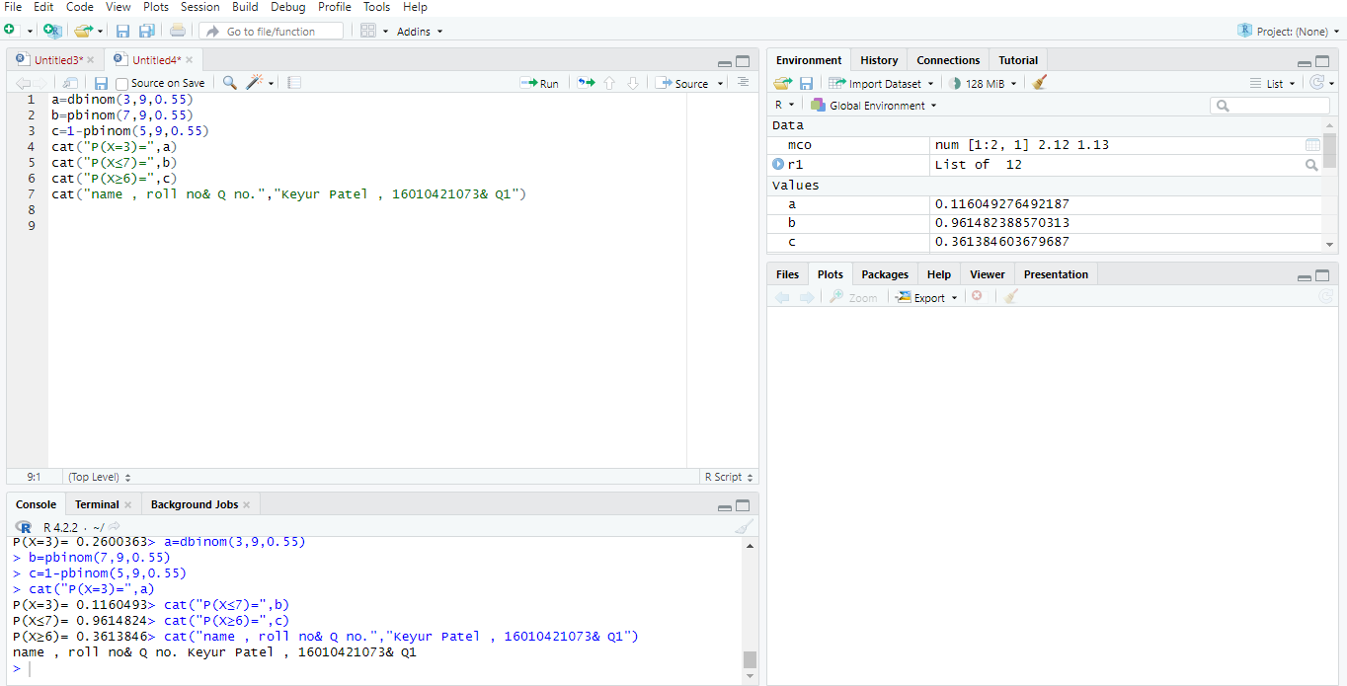

**Q.2 If X is Poisson Distribution mean 0.35**

**Write R-program to evaluate and print (i) P(X=2) (ii) P(X≤2) (iii) P(2≤X≤5)**

**Exponential Distribution**

**Code**

m=0.35

a=dpois(2,m)

b=ppois(2,m)

c=ppois(5,m)-ppois(1,m)

cat("P(X=2)=",a)

cat("P(X≤2)=",b)

cat("P(2≤X≤5)=",c)

cat("name , roll no& Q no.","Keyur Patel , 16010421073& Q2")

**output**

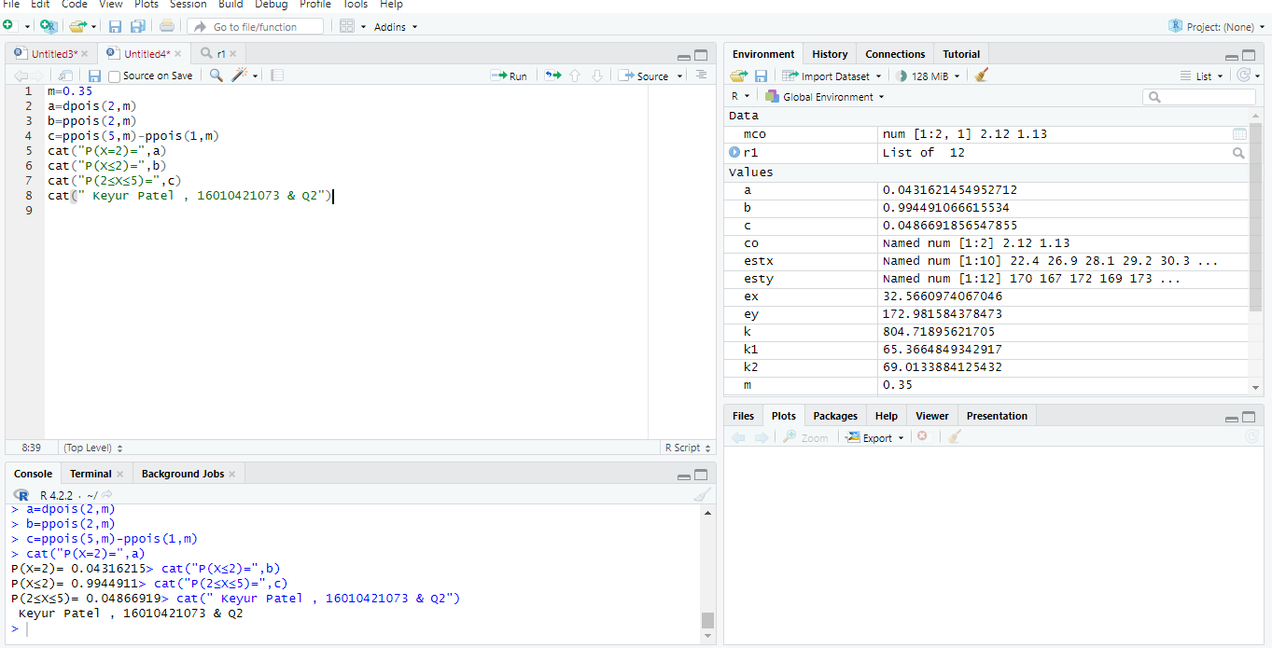

Q3. **If X is Exponential Distribution with mean 10. Write R-programme to evaluate and print**

**(i) P(X>4) (ii) P(X<12) (iii) P(14< X<20).**

**Find value of k such that P(X<k) = 0.9.**

**Code:**

pa=1/10

a=pexp(12, pa)

b=1-pexp(4, pa)

c=pexp(20, pa)-pexp(14, pa)

k=qexp(.9, pa)

cat("P(X>4)=",b)

cat("P(X<12)=",a)

cat("P(14<X<20).=",c)

cat("The value of k is ",k)

cat(" Keyur Patel , 16010421073 & Q3")

**Output:**

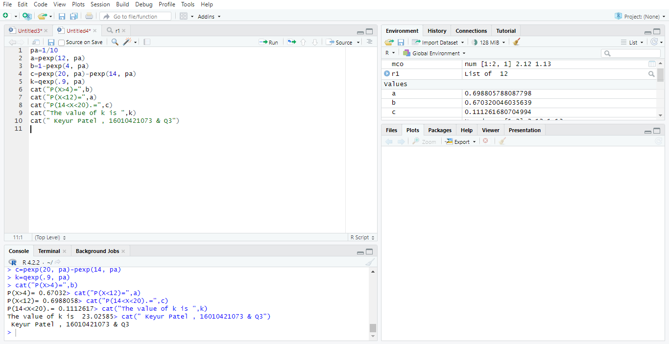

**Q.4**

**If X is Normal Distribution with mean 42 and standard deviation 24. Write R-programme to evaluate and print (i) P(X>50) (ii) P(X<12) (iii) P(30< <54). Find value of k1 such that P(X<k1) = 0.9 Also find k2 such that P(X>k2) = 0.6**

**P(X<=K2)+P(X>K2) =1**

**P(X>k2) = 0.6**

**1- P(X<=K2)=.6**

**P(X<=K2)=0.4**

**Code:**

a=pnorm(68,42,24)

b=1-pnorm(75,42,24)

c=pnorm(75,42,24)-pnorm(60,42,24)

k1=qnorm(.9,42,24)

k2=qnorm(.6,70,5)

cat("P(X<68) =",a)

cat("P(X>75) =",b)

cat("P(60< X<75)=",c)

cat("value of k1 such that P(X<k1) = 0.9 is ",k1)

cat("value of k2 such that P(X>k2) = 0.6 i.e P(X<k2) = 0.6 is",k2)

cat("name , roll no& Q no.","Keyur Patel , 16010421073 & Q4")

**Output:**

